Recruitment Pack: Assistant Director
Peter Pan
by J M Barrie

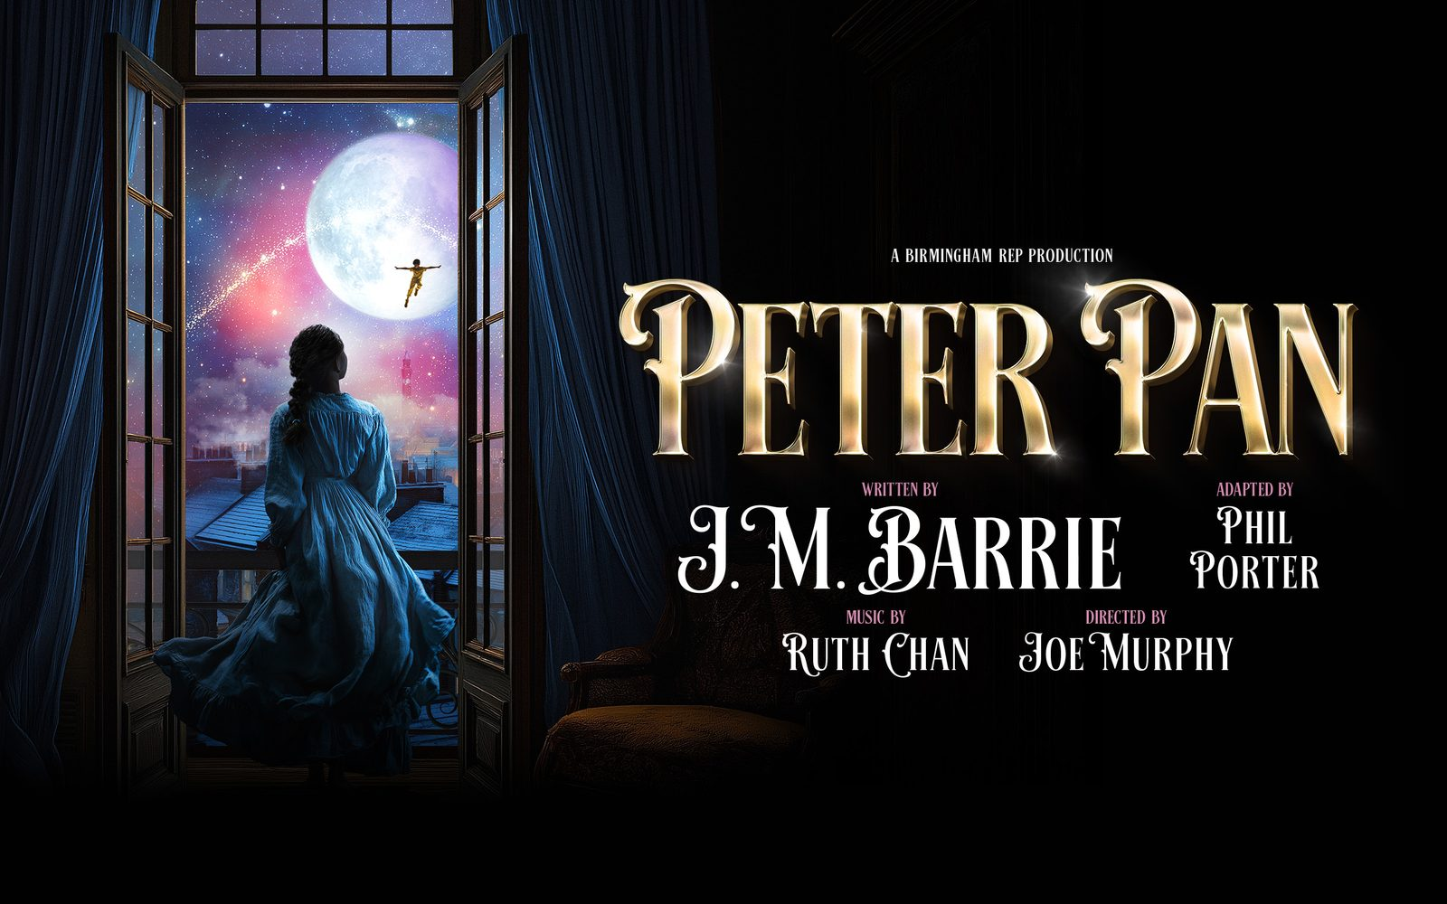
The Rep are looking for an Assistant Director for our upcoming production of Peter Pan by J M Barrie, adapted by Phil Porter, with original music by Ruth Chan, designed by Hayley Grindle and Directed by Joe Murphy.

The production opens at Birmingham Rep in November 2026 and runs until January 2027.

About the Production
Bursting with imagination, this faithful reimagining of J. M. Barrie’s beloved children’s classic will be brought to life with a touch of Rep magic this Christmas. A dynamic cast of 13 actor-musicians will take to the House stage, guiding audiences on an enchanting journey from the Darling family’s Victorian Birmingham bedroom to the boundless world of Neverland.
This ambitious production combines theatrical innovation with storytelling at its finest, featuring breath-taking performer flying, intricate puppetry, and sophisticated actor cover-track arrangements - promising a visually spectacular and emotionally engaging experience for audiences of all ages.
Key Dates
R&D Workshop Week (Birmingham Rep) | w/c 3rd August 2026 (5 days)
Rehearsals week 1 (Birmingham Rep) | w/c 12th October 2026
Rehearsal week 2 (Birmingham Rep) | w/c 19th October 2026
Rehearsal week 3 (Birmingham Rep) | w/c 26th October 2026
Rehearsal week 4 (Birmingham Rep) | w/c 2nd November 2026
Technical Rehearsals (Birmingham Rep) | Commences 6th November 2026
First Preview (Birmingham Rep – The House) | Wednesday 18th November 2026
Press Night (Birmingham Rep) | Tuesday 24th November 2026
Final Performance at Birmingham Rep | Sunday 17th January 2027

Please note, full commitment is required for the entire rehearsal, technical and preview period. Attendance to the workshop in August is desired but not a mandatory requirement.

Person Specification
Essential criteria:
- A keen interested in Directing, with interest in pursuing a career in Directing in their future.
- Demonstrable experience of working as an Assistant Director on productions of scale or complexity
- For this role, we are looking for applicants who are based within the West Midlands
- Right to work in the UK
It’s important to us that The Rep reflects the communities we serve and therefore we particularly welcome applicants from the global majority and D/deaf & disabled communities as these groups are not as well represented as we want them to be.
Role and Responsibilities:
- Supporting the Director through the rehearsal process, actors with line learning, running research as required and aiding the smooth running of the production
- Support the requirements of the rehearsal room to note take, delivering written and video records of progress, and other tasks as requested
- To work closely with the Director and Music team in creating the Understudy / Cover plan
- To lead understudy rehearsals and ensure understudy cover within the acting company in a swift and thorough manner post Press performance (Tuesday 24th November 2026).
- Support the creative, producing and technical teams to ensure effective and efficient lines of communication between departments
- Support the smooth delivery of accessible performances during the run and the smooth-running of press, marketing and educational events associated with the production.
- Taking an active role in contributing to the good welfare of the company, helping to build a creative and accessible environment in which everyone is empowered to do their best work
- Other reasonable duties to aid the smooth running of the production.

Fee
£5,200 to cover all work delivered during prep, rehearsals and tech until the press performance at The Rep on a full-time basis.

Should the candidates home address be more than 25 miles from The Rep, travel expenses will be reimbursed, and accommodation will be covered either in provided accommodation or in relocation allowance.

An additional 5 days at £140 per day for the workshop week commencing 3rd August 2026.
Total fee = £5,900

How to Apply:
- Submission of CV via the application link.
- Answers to the questions below submitted via the application link. Each answer can take the form of a written response (1,500 characters) or audio recording (2 minutes). Please communicate with us in a way that suits you best.
  - Outline your experience and how you feel it makes you suitable for this role.
  - Please tell us about your connection to the West Midlands and why you want to be a part of this show.

APPLY HERE

Applications close: Midnight on Sun 31 May 2026
All applicants will be contacted of the outcome of their application.
If shortlisted, you will be invited to an interview with Joe Murphy (Artistic Director) & Faith Whenham (Senior Producer). Interviews will be held over the weeks commencing 8 / 15 / 23 Jun 2026.
Interviews will take place online.
If you have any questions about the recruitment for this role, please contact peterpan.casting@birmingham-rep.co.uk

